Group Members Details:

* 16010122283 – Hitanshi Patil
* 16010122284 – Harikrishnan Gopal
* 16010122288 – Aditya Raut
* 16010122294 – Adhiraj Patole

TY BTech Computer Engineering

B Division B-4 Batch

**Introducing John the Ripper**

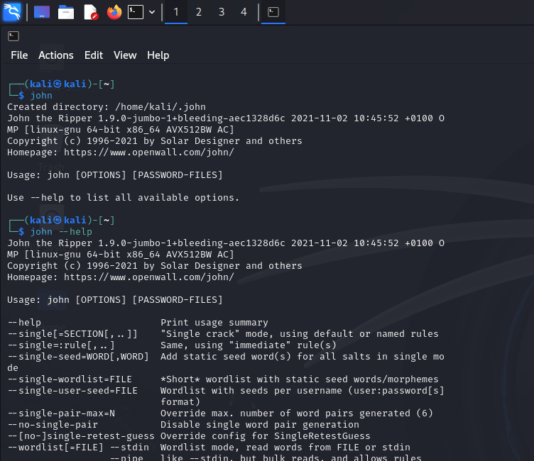

Basic usage of John The Ripper:

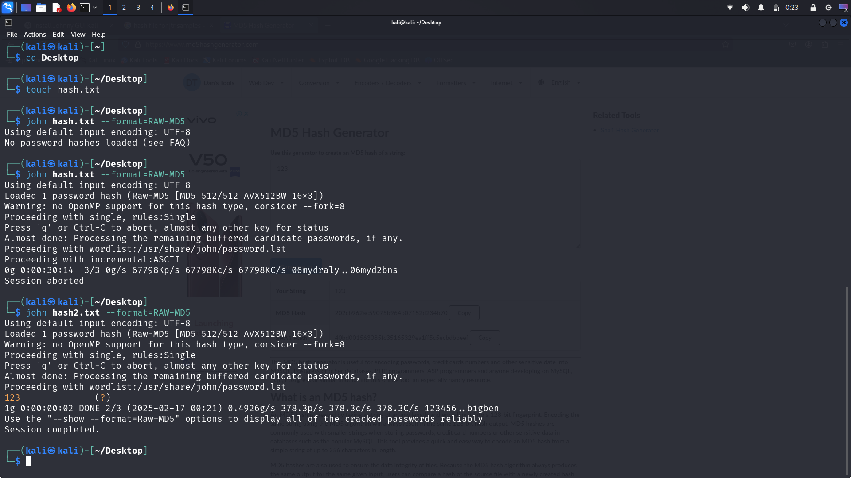

**Formats Supported in John the Ripper**

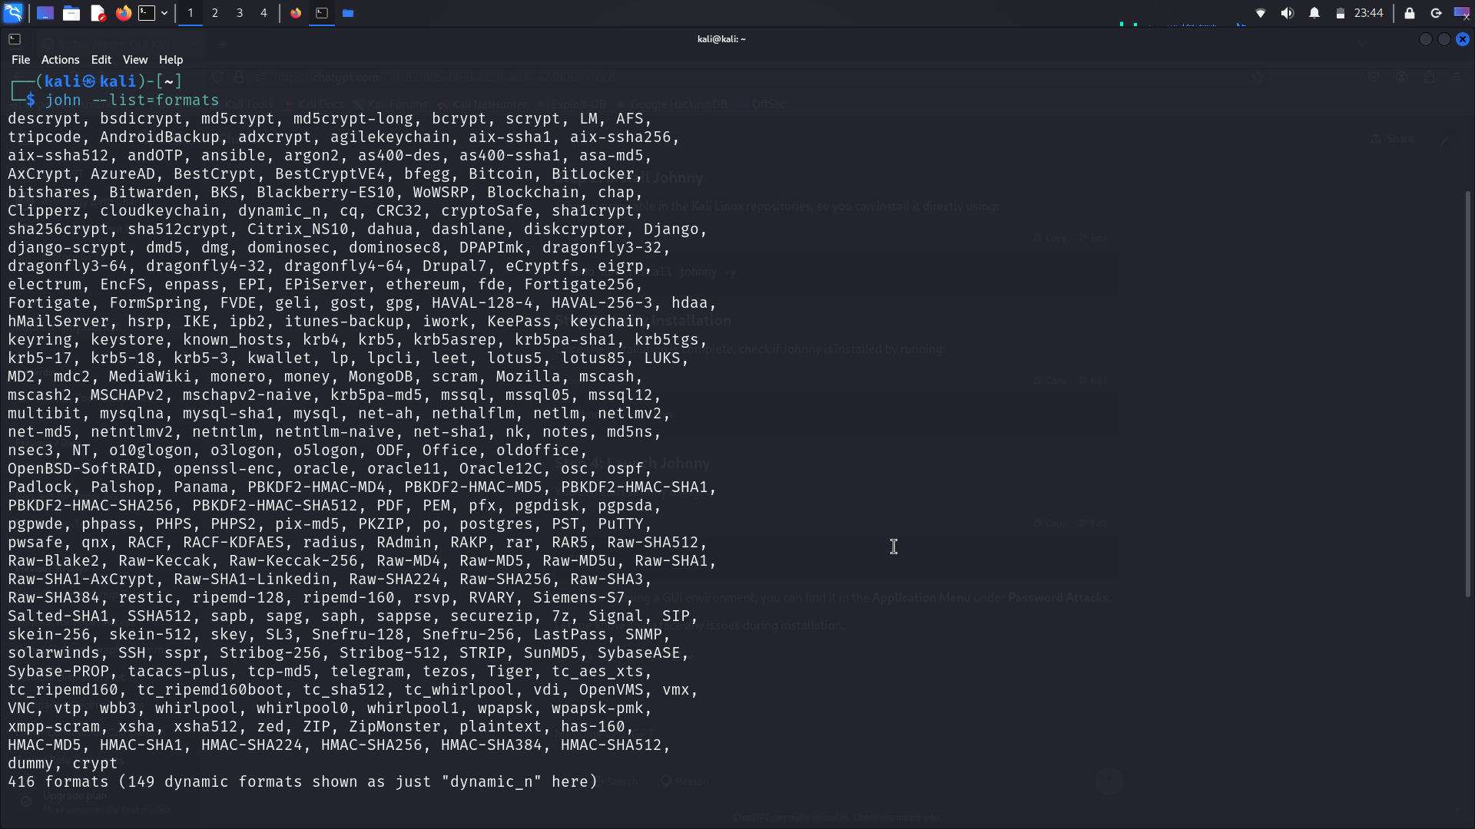

**Find the Hash Format in files**

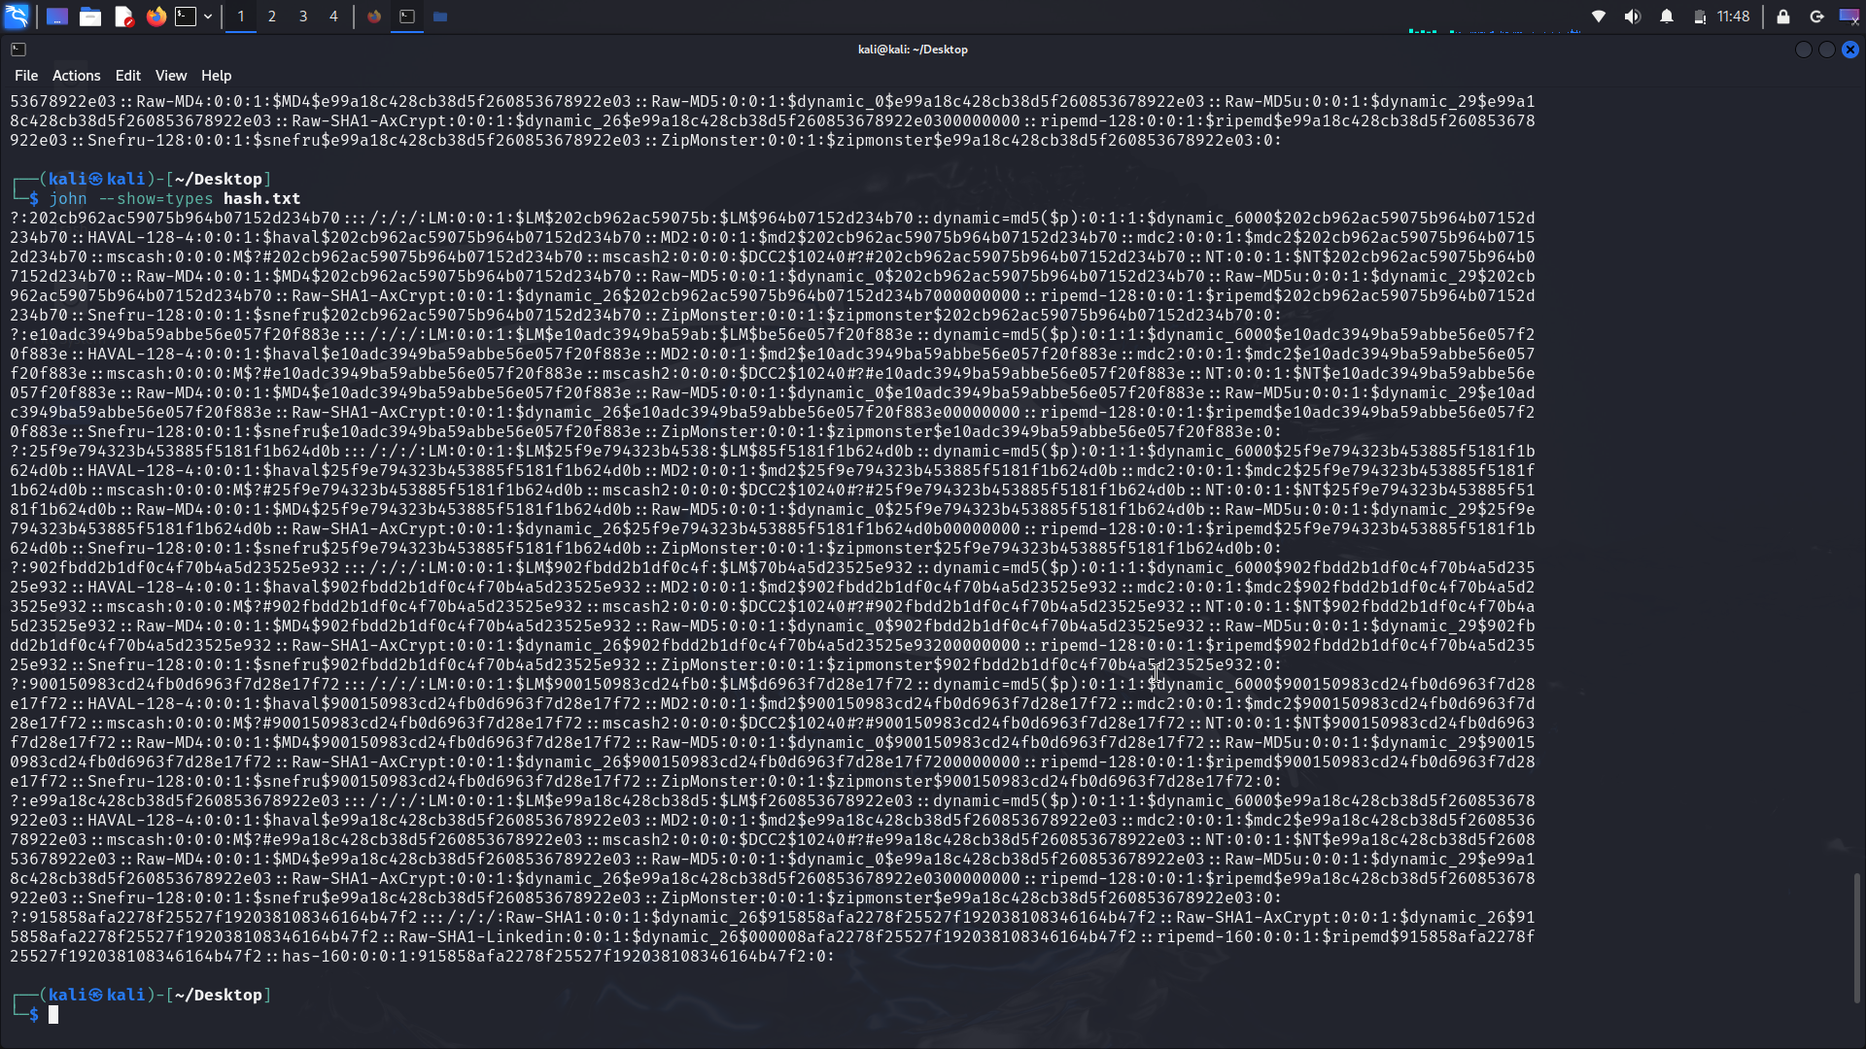

Hash generation:

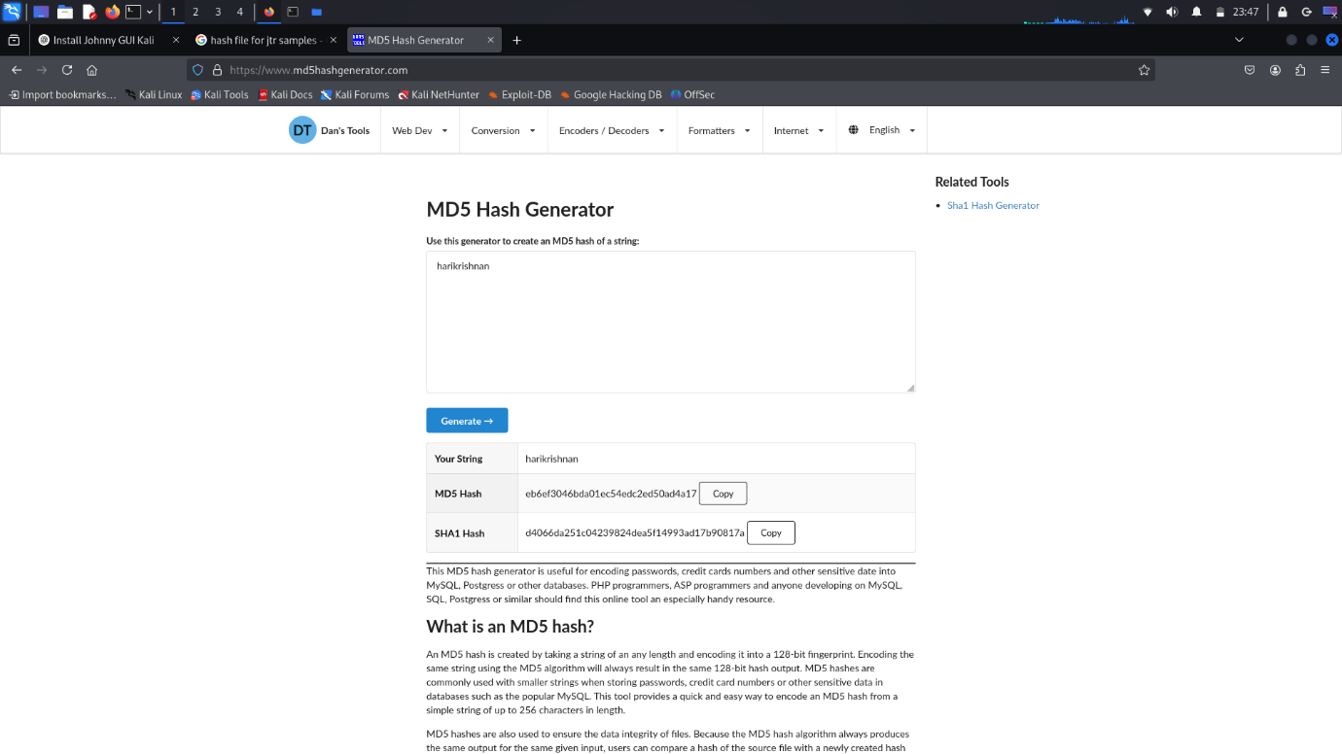

**CLI: Single Crack Mode**

Hash file creation (single_mode.txt)

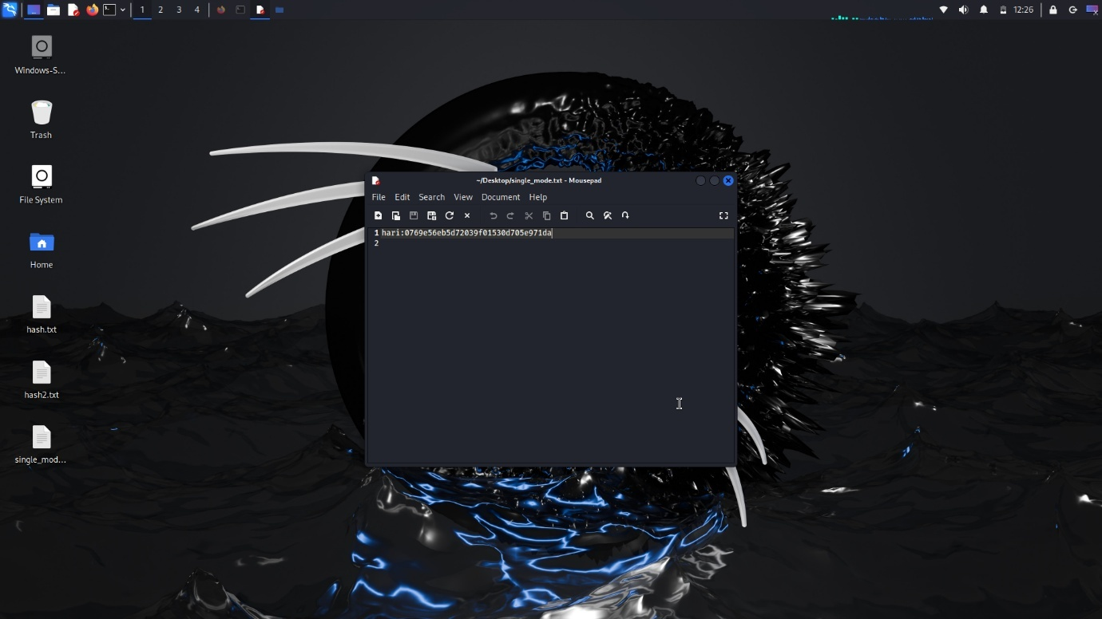

Single Crack mode:

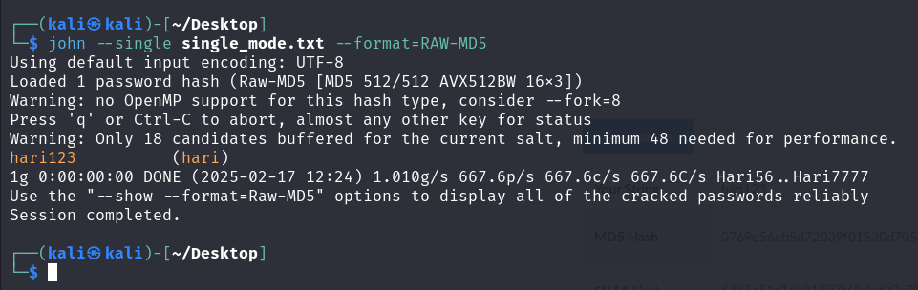

**CLI: Wordlist Mode**

Wordlist Creation (wordlist.txt)

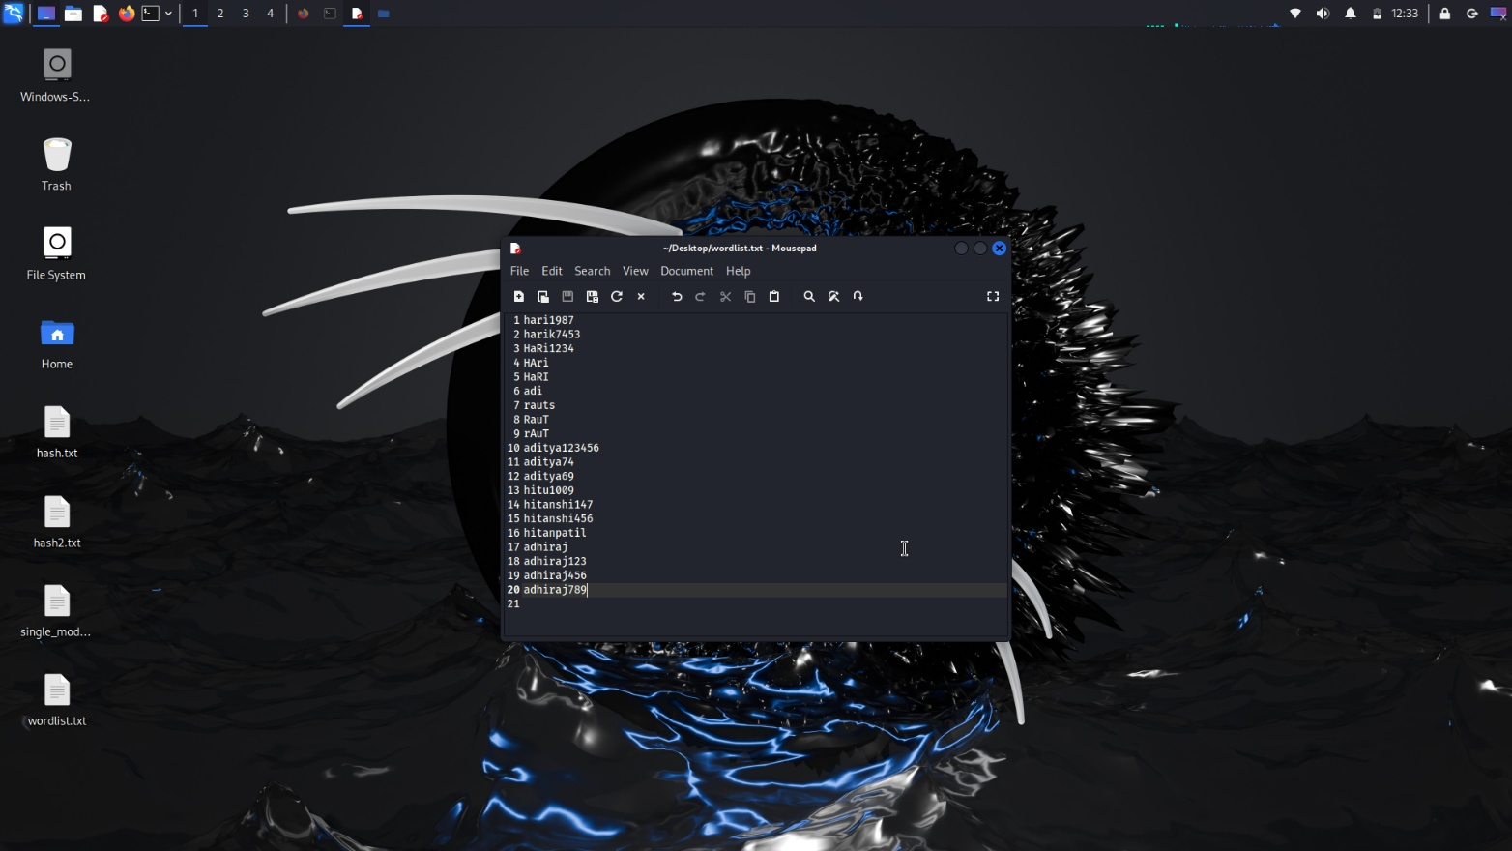

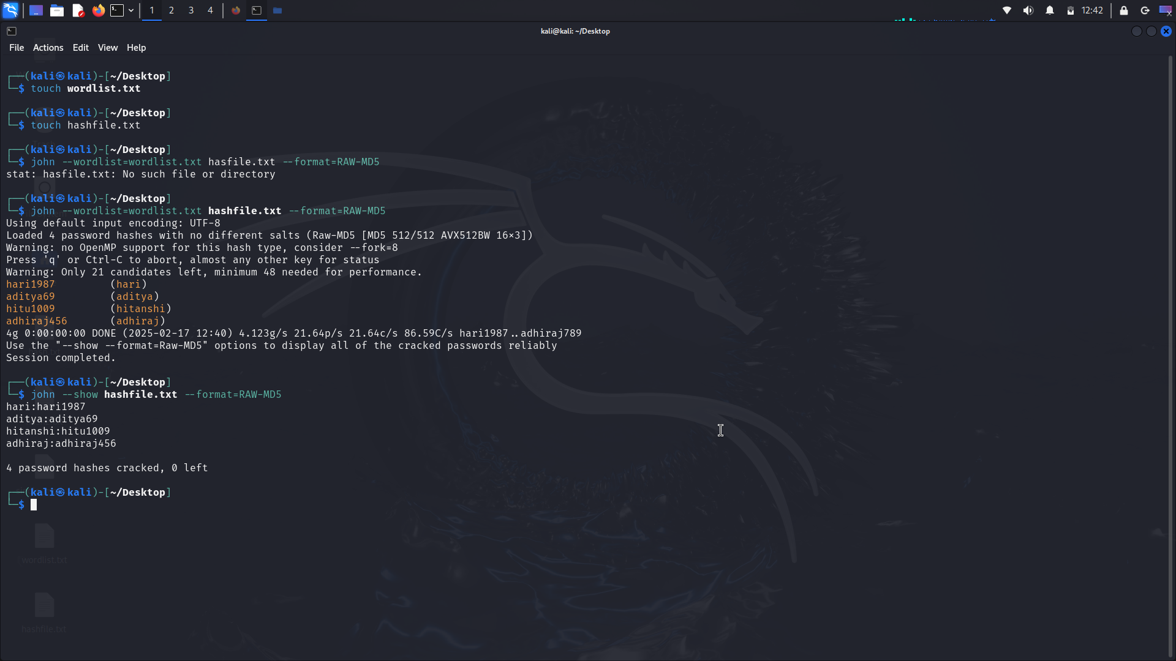

**CLI: Incremental Mode**

ShiftToggle in Incremental mode:

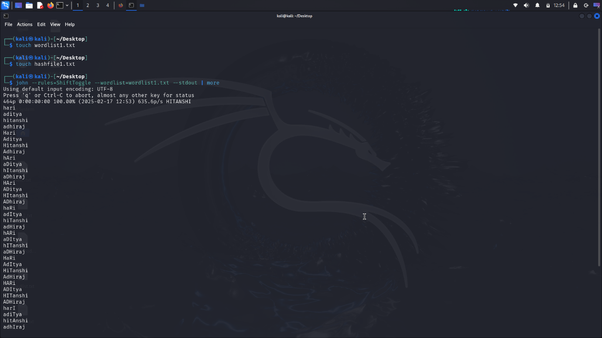

Incremental mode:

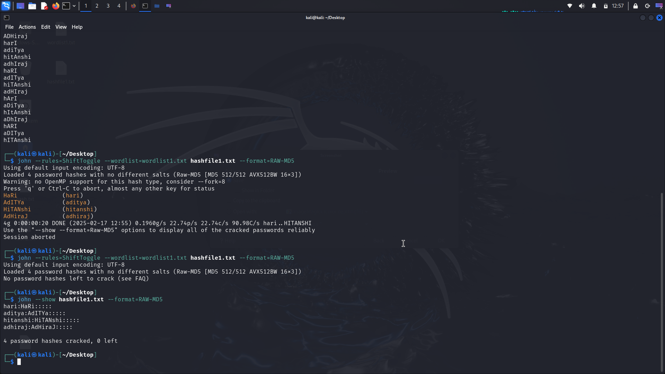

**CLI: Password cracking of ZIP file**

Password protected ZIP file creation (Files.zip):

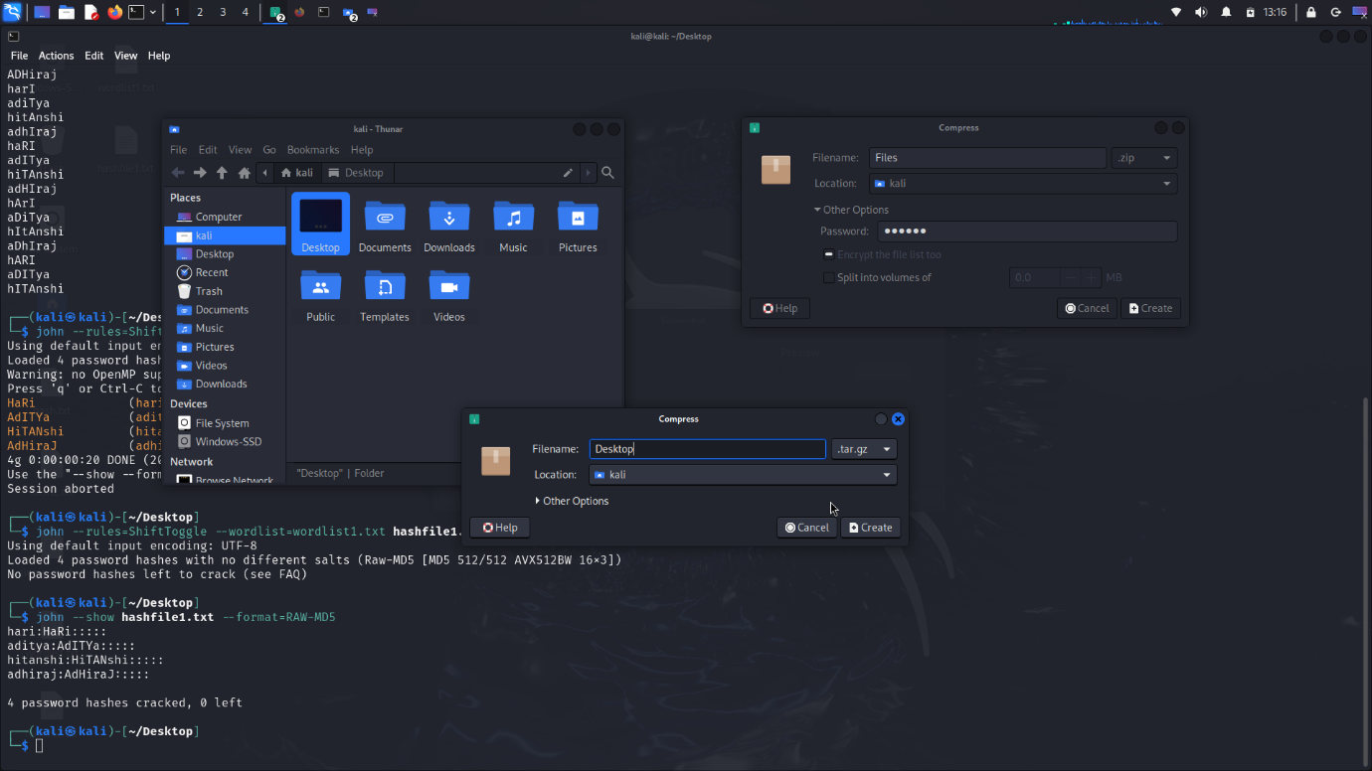

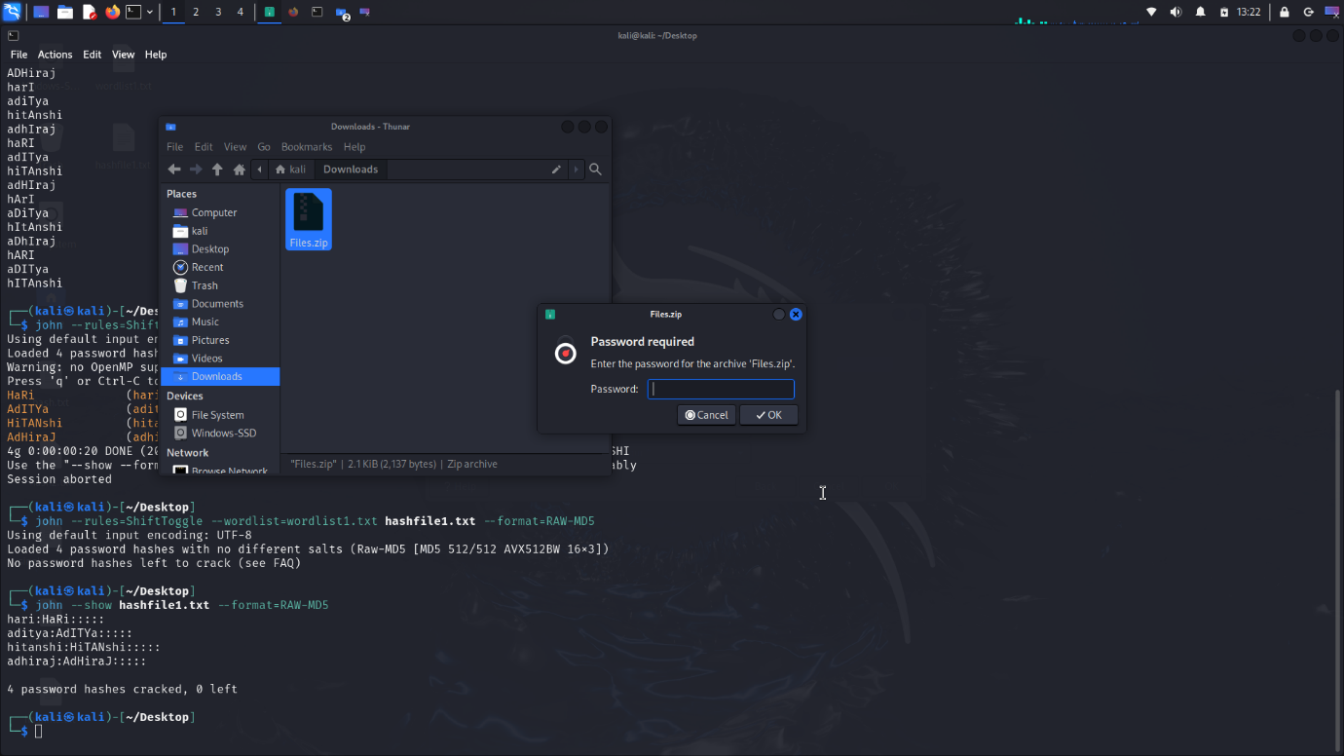

Password cracking on zip files:

Zip file hash:

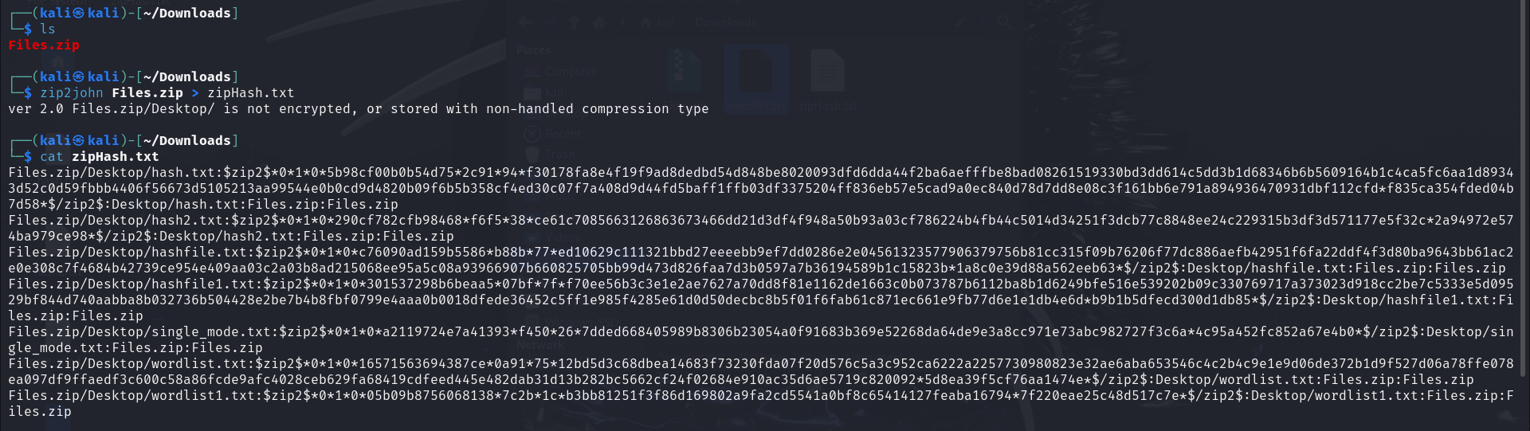

Password cracking on zip files:

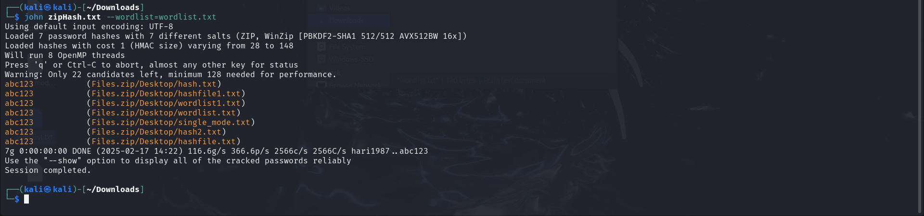

**Exploring the John the Ripper GUI**

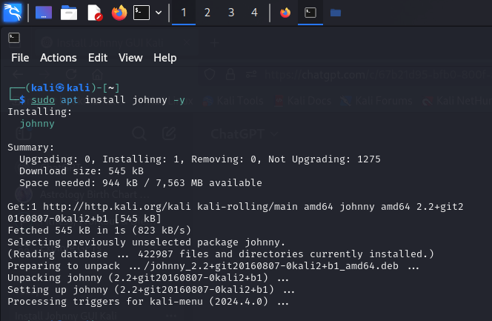

GUI:

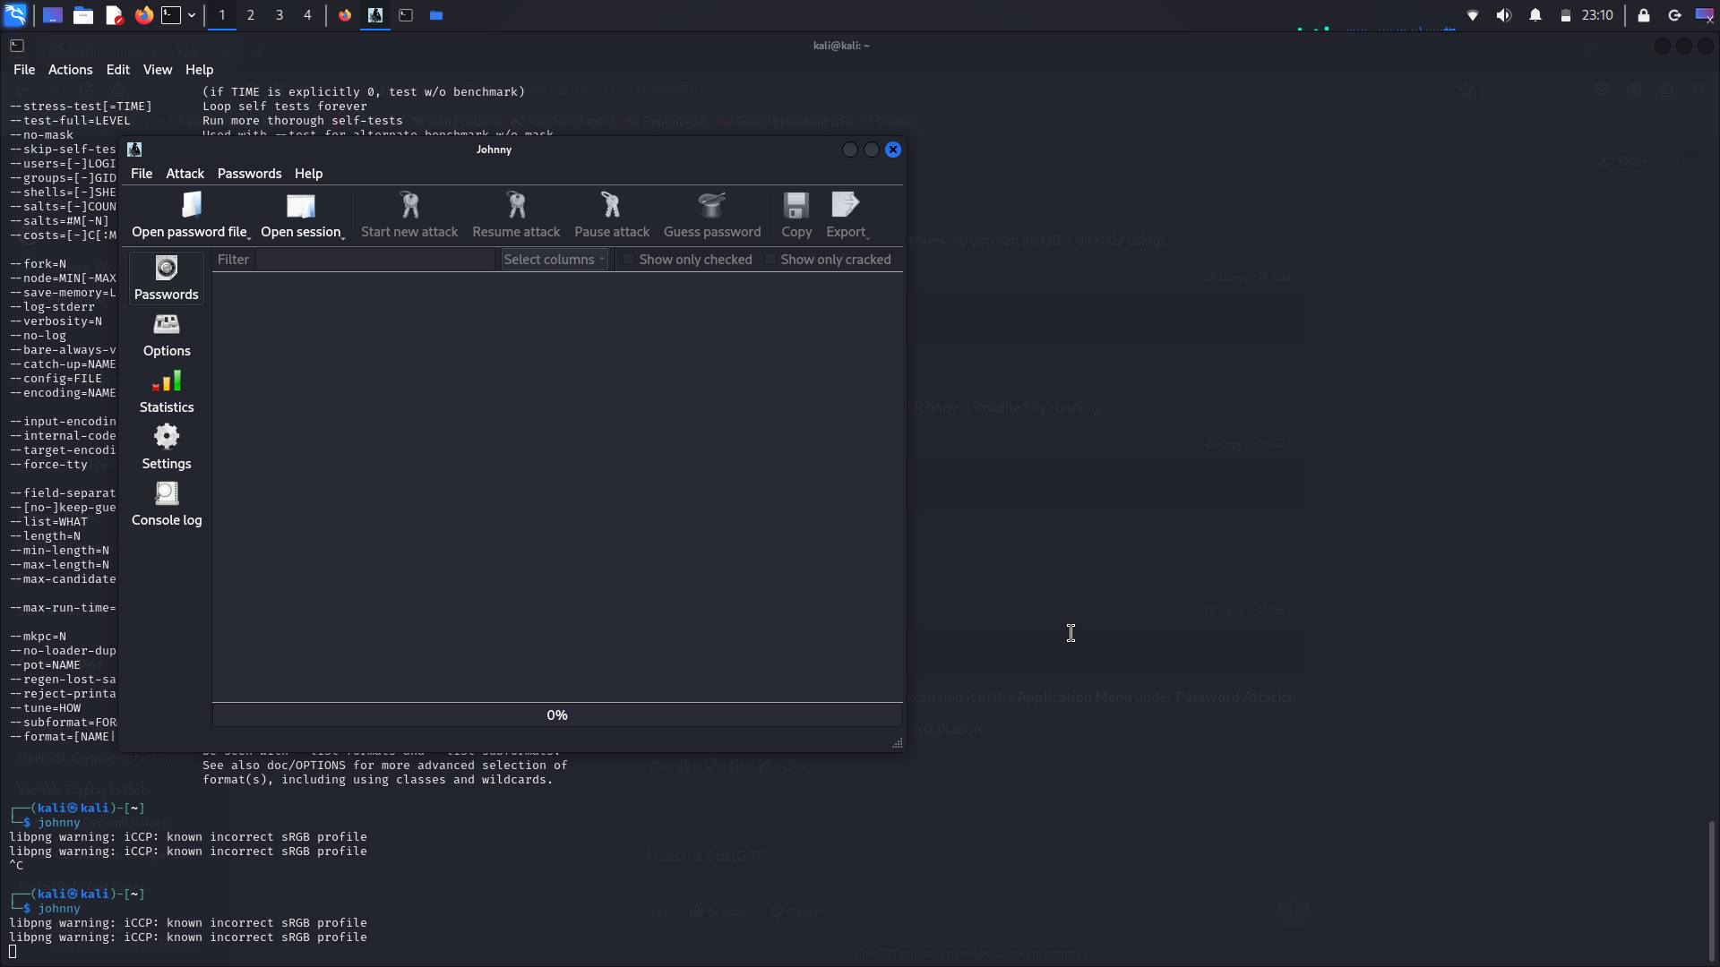

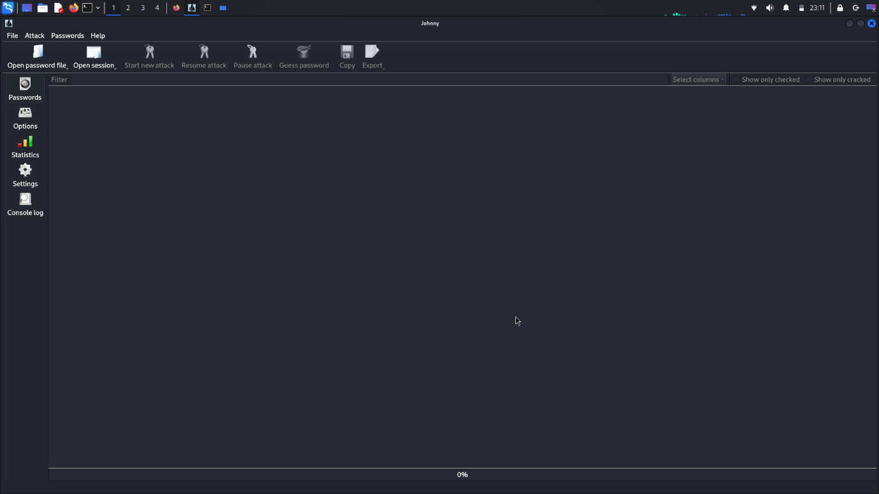

**GUI Mode: Multi-Mode Demonstration**

Open Password file:

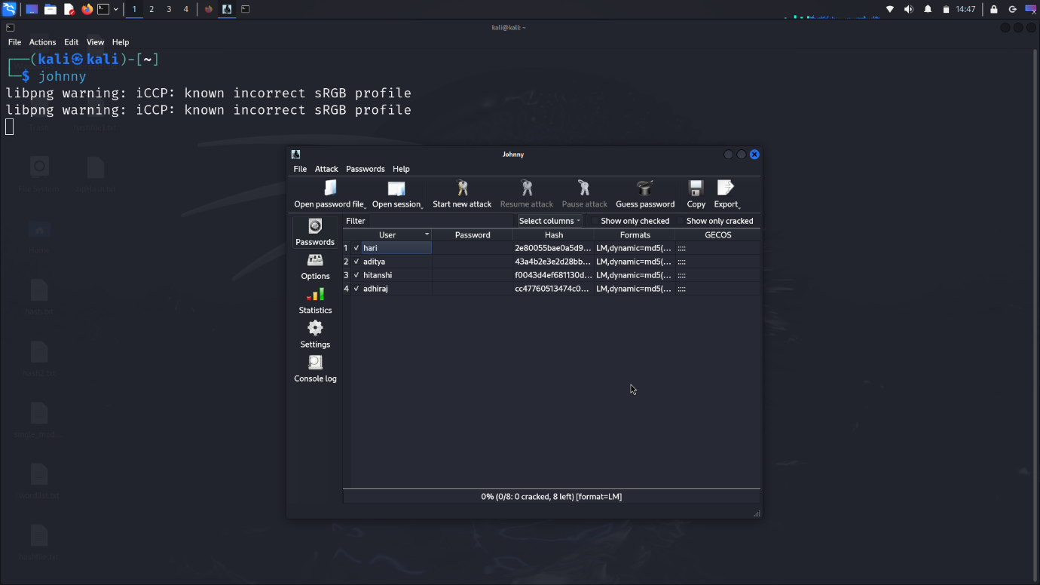

Using Single Crack mode:

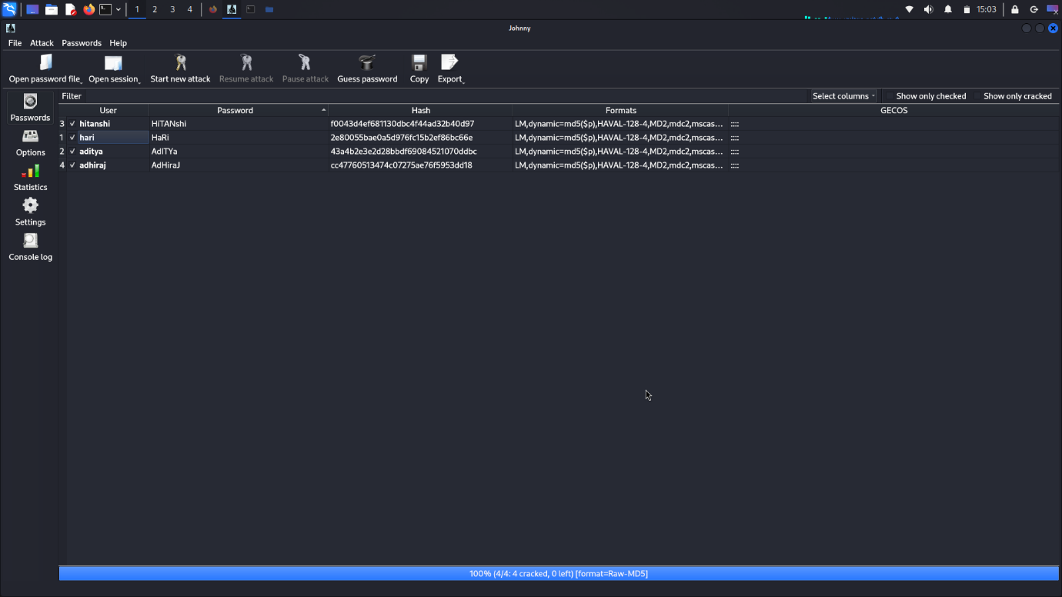

Open wordlist file:

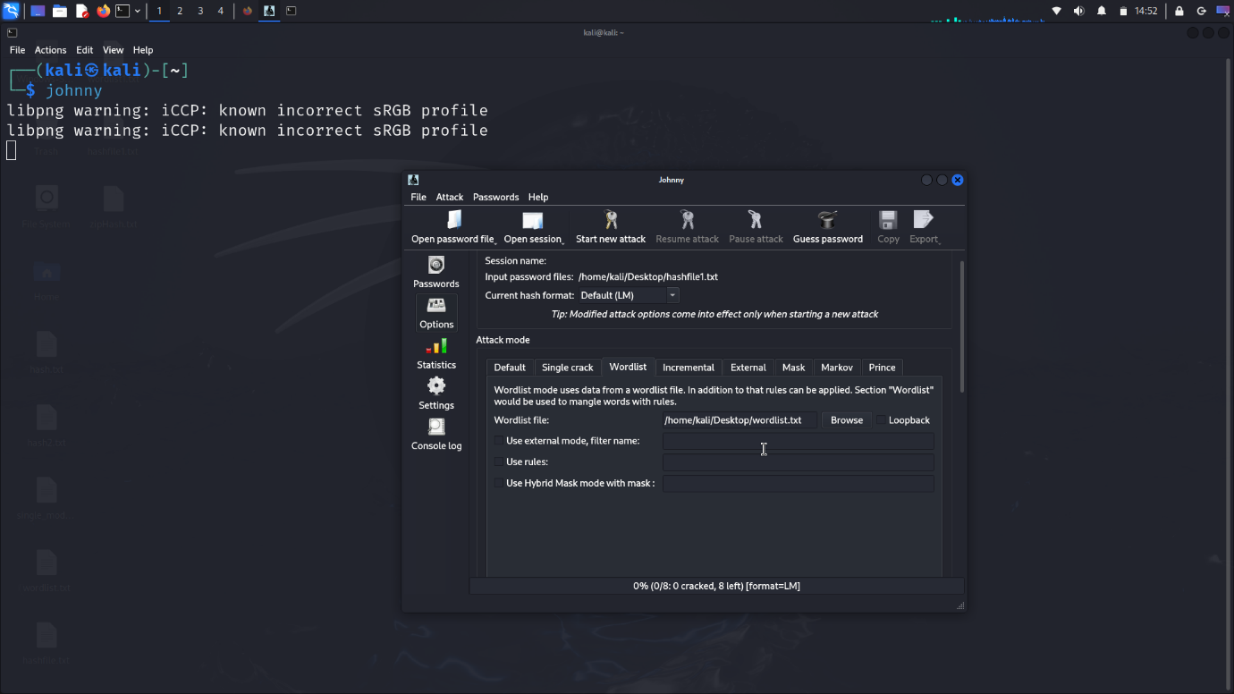

Using wordlist mode:

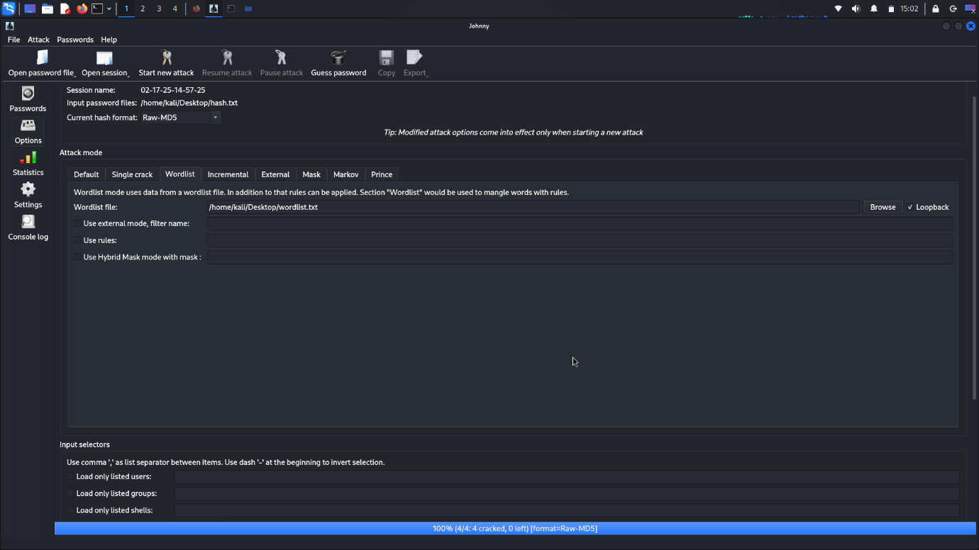



Using Incremental mode:

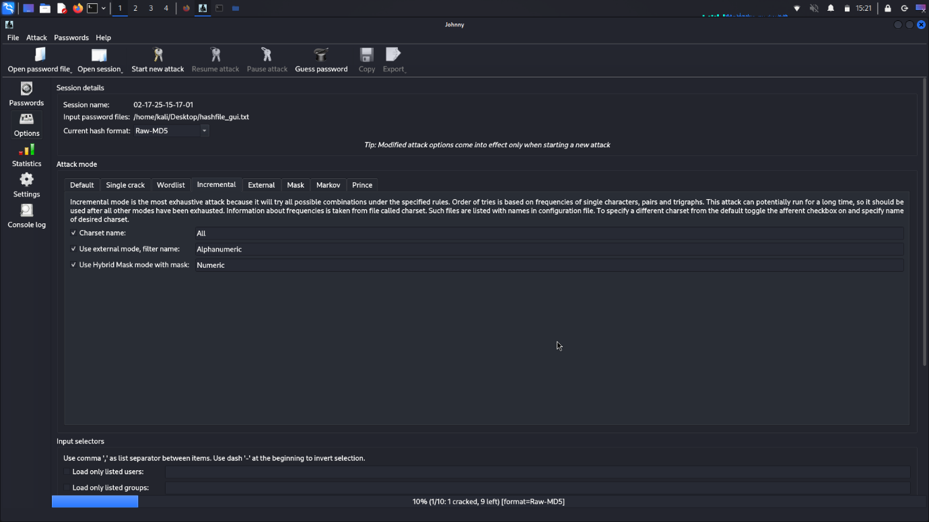

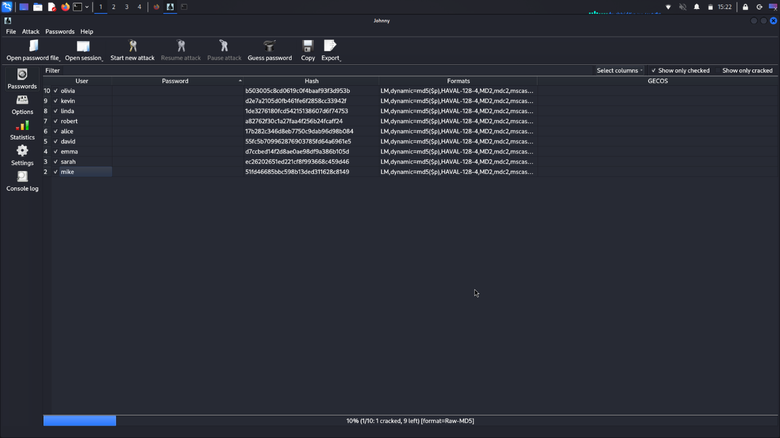

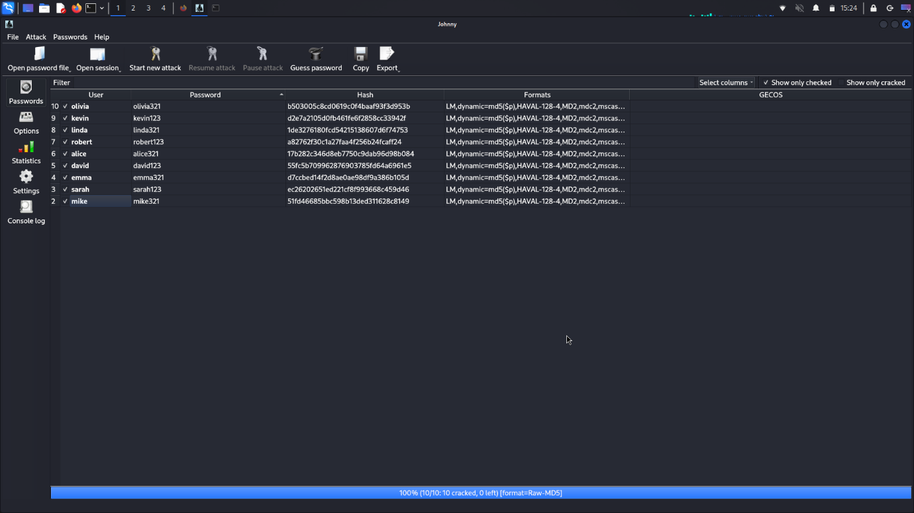

**Implementing fork() for Multiprocessing**

Using 2 Forks:

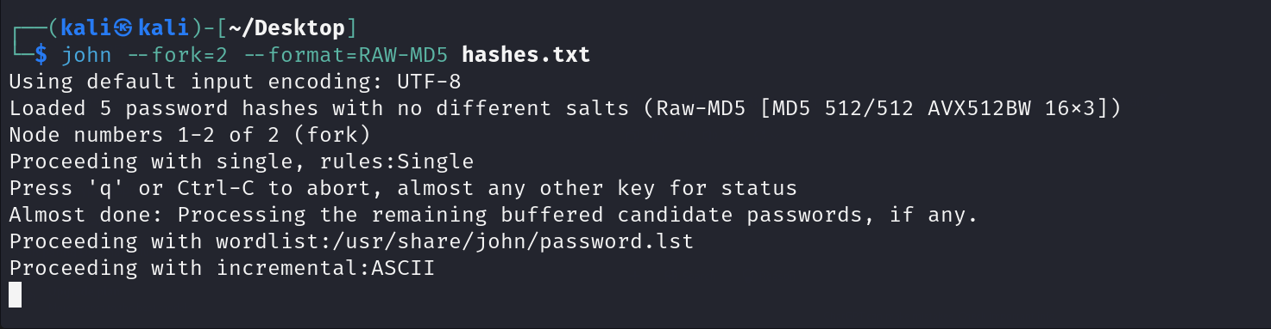

Verifying Forked John the Ripper Processes with ps aux:

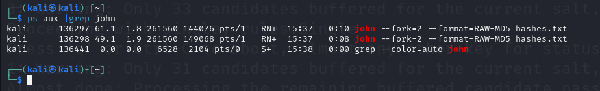

Using 4 Forks:

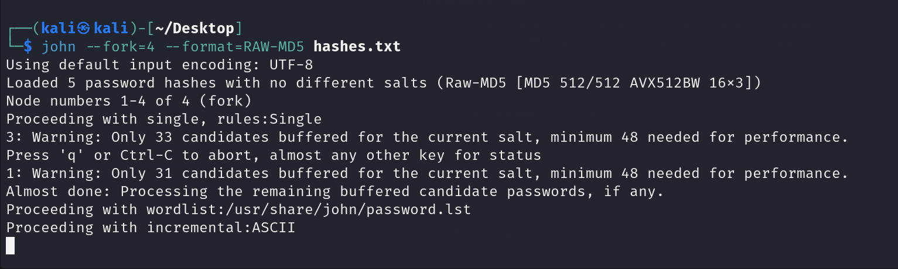

Verifying Forked John the Ripper Processes with ps aux:

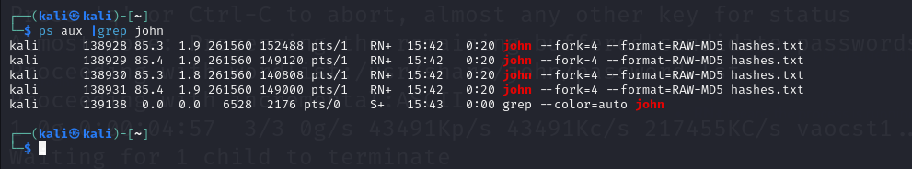

**Basic Implementation of John the Ripper in Python**

Python code (Full code Uploaded on GitHub):

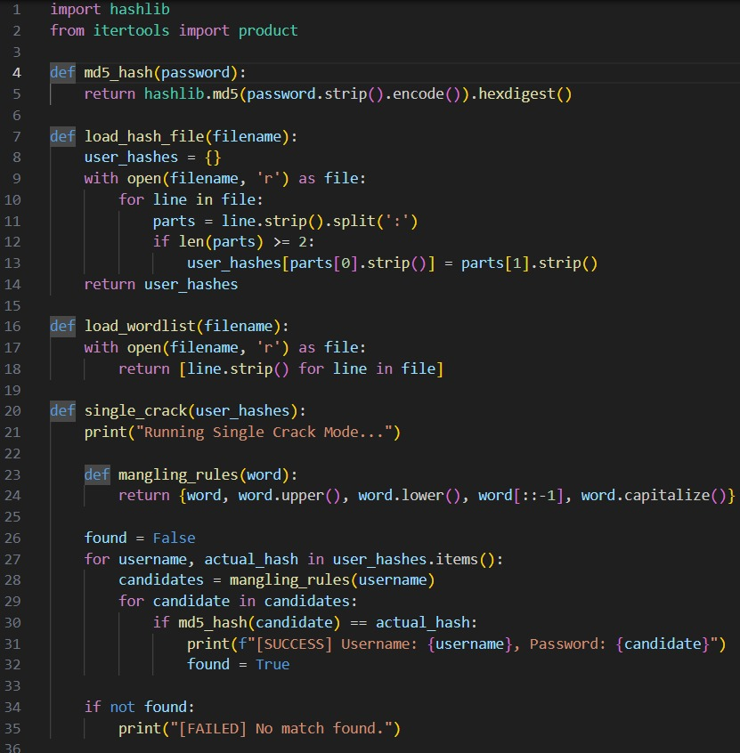

Files:

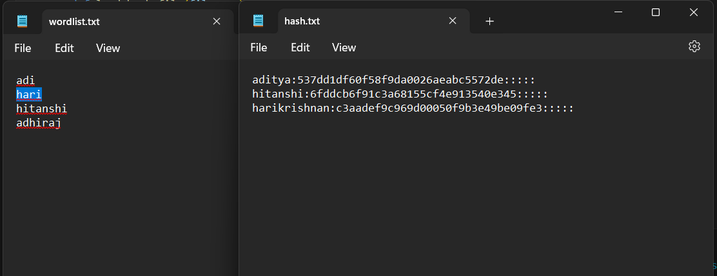

Output:

Using Single Crack Mode:

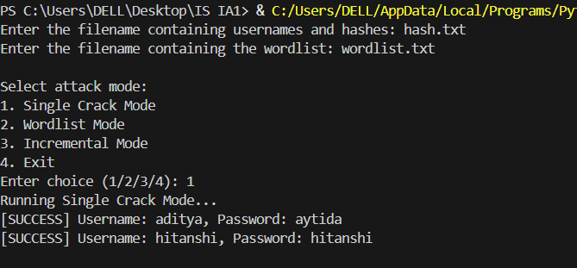

Using Wordlist mode:

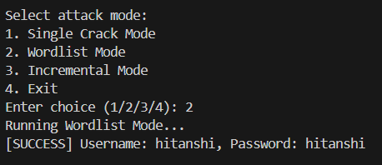

Using Incremental mode:

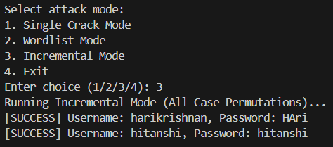

Exit:

